Java.util.Collection.sort

**🡪java.util.Collections.sort()** method is present in java.util.Collections class. It is used to sort the elements present in the specified [list](https://www.geeksforgeeks.org/list-interface-java-examples/) of Collection in ascending order. It works similar to [java.util.Arrays.sort()](https://www.geeksforgeeks.org/arrays-sort-in-java-with-examples/) method but it is better than as it can sort the elements of Array as well as linked list, queue and many more present in it.

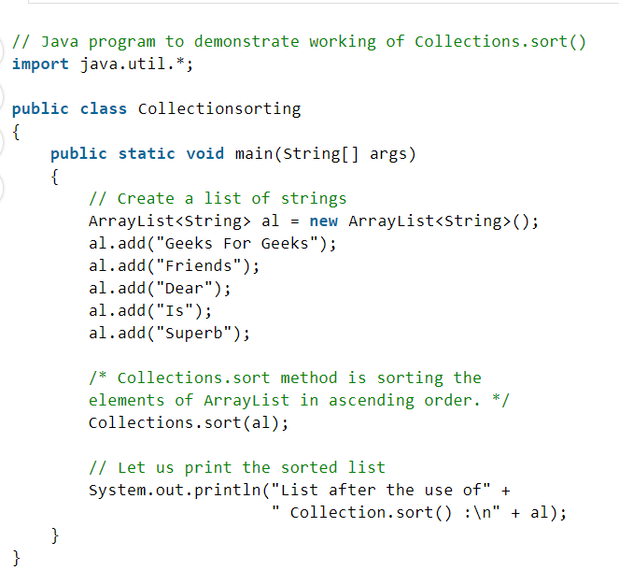

🡪For sorting the arrayList in the descending order :

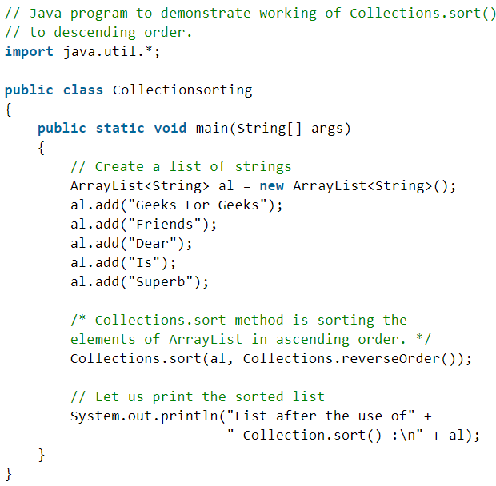

🡪 **Sorting an ArrayList according to user defined criteria.** We can use Comparator interface for this purpose.